**Online Shopping and Delivery System**

-Nikhil More (B18CSE046)

-Rituraj Kulshresth (B18CSE046)

-Saurabh Shashikant Burewar (B18CSE050)

**Contents**

|  |  |  |
| --- | --- | --- |
| Index | Contents | Page No. |
| 1. | Introduction | 3 |
| 2. | Objective | 5 |
| 3. | Terms of Usage | 6 |
| 4. | System Analysis | 7 |
| 5. | Feasibility Study | 9 |
| 6. | Activity Diagram | 12 |
| 7. | Class Diagram | 14 |
| 8. | Use Case diagram, | 16 |
| 9. | Process logic | 18 |
| 10. | System Security Measure | 19 |
| 11. | Current State of The Project | 20 |
| 12. | Future Scope of The Project | 21 |
| 13. | References | 22 |

**Introduction**

Due to the advancement in technology people wish to ease their life thus they want their needs brought to them without spending a lot of time and energy. Online Shopping and Delivery system is a web-based project for internet-based shopping.

Our Shopping and delivery system is built for the students and faculty members of IIT Jodhpur who wish to ease their way of life. Jodhpur has got burning summers and unpredictable rainy seasons. The distance of the community center from the hostel area is around 2KM. It is very difficult for students to get the items of their need from the community center. Moreover, due to the strict routine of the students, they are unable to find the time to visit the community center.

When our delivery system was not present the Students had to go to the community center and stand in the crowd in order to buy the product they required. If the product was not available at the community center, they had to come back empty handed and sad.

With our online shopping and delivery system people can now check if the product is available at the shop in the community center.

If they wish to go to the community center and buy the product, they can, if they want to stay in their room all cozy, then they can order the product and pay either in cash on delivery or at the time of order, online using debit card. This will save a lot of time and help the general public in case they urgently require the product.

The delivery system gets the info about any order placed directly. It is their duty to collect the product from the designated seller and deliver it to the customer according to the data provided.

Our project is local i.e., its only available to the students and faculty inside the campus of IIT Jodhpur.

**Objective**

Today the internet and its boom have created a new economic scenario that not only stresses on the classical concept of the “*product*” but also on the modern concept of “*service*”. It is this level of service that dictates whether a commercial venture will succeed or not in the market. To provide a high accessibility of service we designed the online shopping website so that potential customers need not go to a physical shop to buy products or services.

The objectives of our online shopping and delivery system are:

* Our website gives all the information about the e-shopping services provided by our online shopping and delivery system.
* It provides ease of access to the customers who wish to buy stuff but can’t, due to the lack of time.
* It provides the customers the facility to pay either by cash or by debit card.
* It provides full details of the product which the sellers are selling at the community center.
* It can save time and help in case someone needs a product urgently.
* It provides delivery in two slots which can be chosen by the customer at the time of checkout.
* The sellers can update the products whenever the stocks are refilled or emptied.
* Customers can buy groceries, stationaries, fruits according to their wish.
* Our product is free to use.

**Terms of usage**

Our product only provides a remote interface between the seller and the customer.

We are in no way responsible for the malfunctioned or damaged products. However, we will handle the damages dealt during the delivery of the product.

In case the product provided by the seller is faulty the customer will themselves have to contact the seller. We will not be responsible to take the product back to the seller. However, we will ensure that the customer get their money back in case their accusation is correct, and the seller is at fault.

This policy will only be valid for a short period of time after the product is bought and will be dependent on the product.

**System analysis**

**Problem Statement:**

Create an online shopping and delivery system which lists all the products sold at the community center of IIT Jodhpur. The students and teachers can access this system from their rooms using our web app. The delivery system will deliver the product at their hostels. This system will accept payment in cash at the time of delivery or online as debit card.

**Administrator:**

The online shopping and delivery system administrator is a super user. He has complete control over the system. The administrator’s duty is to verify and add a seller to the existing list of sellers. All the details regarding each transaction is sent to the Administrator. The admin can view and remove all details present in the log of the online shopping and delivery system.

**Shop owner:**

Any user can submit a shop creation request application to the administrator’s mail. When the request is approved by the administrator, the requester is notified, and from there on the role the role of shop owner begins. It is the duty of the shop owners to add the products available at their shops. Whenever a product goes out of stock the seller must update the list of products that he is selling and are available. The shop owner has full rights to update this table. The shop owner can decide to remove the shop by requesting the administrator by mail. From the time of adding a product to the table to the time when the delivery manager comes to pick up the product, it’s the responsibility of the shop owner.

**Delivery Manager:**

When a customer places an order at the portal the delivery manager gets notified about this order. It is his duty to pick up the product from the shop that the customer has chosen and deliver this product within the time slot that the customer has chosen. It is his duty to collect cash in case the customer has chosen cash on delivery.

**Customer:**

The whole Delivery system is built in order to facilitate the customers wish. The customers can register at the portal and then log in. After logging in they have access to view all the products that the shop owners are selling and can easily select an item and buy it or add to cart and further check for other products. The customers have an option to pay for the order at the time of placing it, by card or pay in cash at the time of delivery. He also has an option to select the time slot of delivery. When the delivery manager comes to the customer in order to deliver the product at the given slot, the customer has to receive the order and pay to the delivery manager in cash if he has not paid the price at the time of placing the order.

**Feasibility Study**

Feasibility is the determination of whether a project is worth doing. The process followed in making this determination is called a feasibility study. This type of study determines if a project can and should be taken. Once it has been determined that a project is feasible, the analyst can go ahead and prepare the project specification which finalizes project requirements.

**Different Type of Feasibility Study: -**

In the conduct of the feasibility study, the analyst will usually consider seven distinct, but inter- related types of feasibility. They are: -

* Technical Feasibility
* Operational Feasibility
* Economic Feasibility
* Social Feasibility
* Management Feasibility
* Legal Feasibility
* Time Feasibility

**Technical Feasibility:**

Technical feasibility is concerned with specifying equipment and software that will successfully satisfy the user requirement; the technical needs of the system may vary considerably, but might include: -

* The facility to produce outputs in each time.
* Response time under certain conditions.
* Ability to process a certain volume of transaction at a Particular speed.
* Facility to communicate data to distant location.

**Operational Feasibility: -**

Operational feasibility is mainly related to human organization and political aspects. The points to be considered are: -

* What changes will be brought with the system?
* What organizational structures are distributed?
* What new skills will be required?
* Do the existing staff members have these skills?
* If not, can they be trained in due course of time?

**Economic Feasibility: -**

Economic analysis is the most frequently used technique for evaluating the effectiveness of a proposed system. More frequently known as cost / benefit analysis; the procedure is to determine the benefits and saving that are expected from a proposed system and compare them with costs. If benefits outweigh costs, a decision is taken to design and implement the system.

**Social Feasibility: -**

Social feasibility is a determination of whether a proposed project will be acceptable to the people or not.

**Management Feasibility: -**

It is a determination of whether a proposed project will be acceptable to the management

**Legal Feasibility: -**

Legal feasibility is a determination of whether a proposed project infringes on known Acts and Statutes, as well as any pending legislation.

**Time Feasibility: -**

Time feasibility is a determination of whether a proposed project can be implemented fully within a stipulated time frame. If a project takes too much time it is likely to be rejected.

**Activity diagram**

Activity diagram is an important diagram in UML to describe the dynamic aspects of a system. Activity diagram is basically a flowchart to represent the flow from one activity to another activity. The activity can be described as an operation of the system.

The control flow is drawn from one operation to another. This flow can be sequential, branched, or concurrent. Activity diagrams deal with all type of flow control by using different elements such as fork, join, etc.

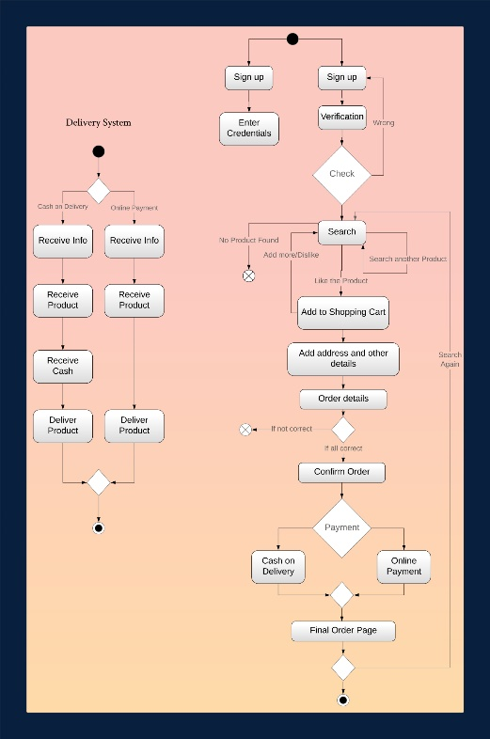

**Class Diagram**

Class diagram is a static diagram. It represents the static view of an application. Class diagram is not only used for visualizing, describing, and documenting different aspects of a system but also for constructing executable code of the software application.

Class diagram describes the attributes and operations of a class and the constraints imposed on the system. The class diagrams are widely used in the modelling of object-oriented systems because they are the only UML diagrams, which can be mapped directly with object-oriented languages.

Class diagram shows a collection of classes, interfaces, associations, collaborations, and constraints. It is also known as a structural diagram.

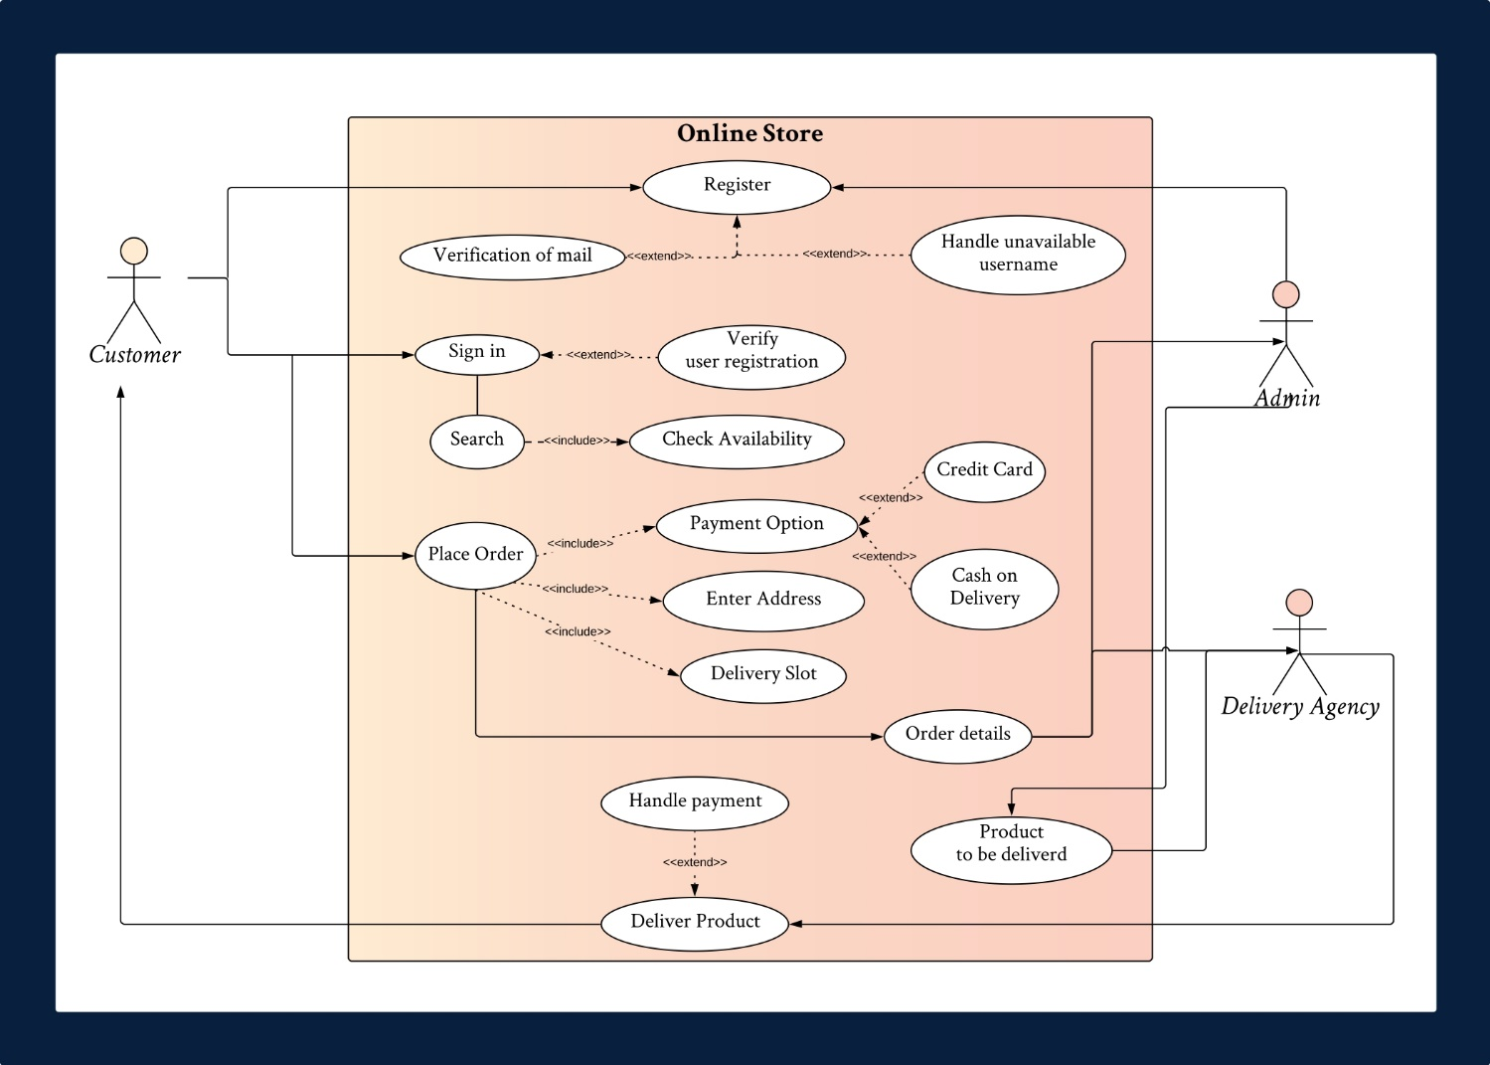

**Use case diagram**

To model a system, the most important aspect is to capture the dynamic behaviour. Dynamic behaviour means the behaviour of the system when it is running or operating. Use case diagram is dynamic in nature.

The internal and external agents are known as actors. Use case diagrams consists of actors, use cases and their relationships. The diagram is used to model the system or subsystem of an application. A single use case diagram captures the functionality of a system.

Hence to model the entire system, several use case diagrams are used.

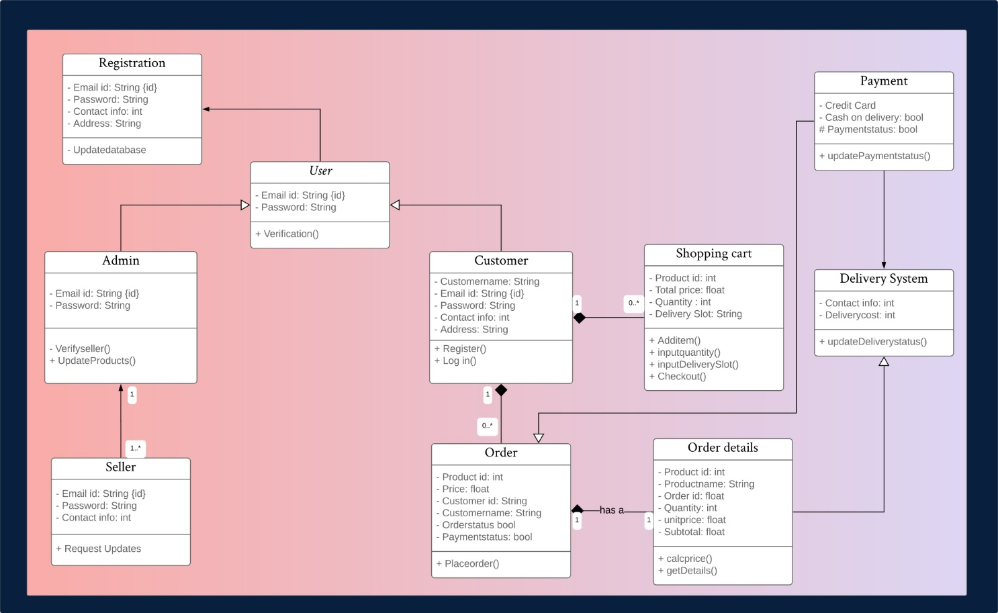

**PROCESS LOGIC**

Process logic is concerned with how the system interacts with users and fulfils their requirements. Being a web-based system, the users of this system can easily access this system through Internet. It provides various functionalities, attracts the user to use it, and makes the user comfortable to work on it.

Before providing access to the application, the user must register as a seller or a customer. It demands for name, password, email id and phone number. If all credentials match the type that is asked, the registration is successful else it asks the user to re-enter the data. If the name and password entered are correct, then one can enter the menu as a seller or a customer depending upon the registration details. Customers can search for the product or update their profiles, under update profile they can change contact and name. Under search, they can search a product that is available and buy it. Seller can update, add, view the products registered under their name. and can change their contents from this place. The passwords of the users are hashed and then stored, in order to maintain the security of our software.

The registration part of the delivery agency is still under way.

**SYSTEM SECURITY MEASURE**

Security is the most important part of any system. It can be either the security of system program functionalities or underlying database. We have very cautious process of authentication of user that no one could change its contents in unauthorized manner. Security and integrity of database are very important for any software system because databases are the backbone of the system. Security need to be implemented at every level of the system so that only authorized user can access the system to update or perform any other significance process. The users must enter the password with at least 8 characters, there must be a capital letter, a small letter, and a special character. If above condition is not met the user will have to choose another password. If it is met, he is successfully registered. All password related data is stored as a hash in order to protect the users’ credentials. Any wrong data cannot be entered as our software checks for a kind of input only. The password data is not stored with the user data as it may harm the security of the system.

The main purpose of the security is to save system from accidentally changes or loss of information or also getting wrong information. The system administrator is the person that can change the information or update the information. He can also grant the permission about who can enter the system and what can they do. Hence, security is the most important topic to be concerned.

**Current State of the project**

Currently the project is only present locally on a PC. It can only give the users access through a terminal window. There is no graphic User Interface and the User Experience is not in the league of great shopping sites.

Online payment system development is under progress. The Return management system is also under development. Currently only the basic structure of the online shopping and delivery system is complete. It has not been integrated with a web application yet.

**FUTURE SCOPE OF THE PROJECT**

Online shopping and delivery system is a web-based project which is made for remote-shopping or shopping through Internet. As the technology advances in future we will try to make this web application an even better experience.

We plan to make a graphic User Interface in order to entertain the users even more and make the user experience better. We will integrate it with a web app or a website. We will also add an online banking option or a debit card option. We plan to increase the reachability of our web app. We also plan to make a mobile application for our online shopping and delivery system.

References

* Md5 Hashing algorithm - <http://www.zedwood.com/article/cpp-md5-function>
* C++ syntax - <https://www.geeksforgeeks.org/>
* Delay Function - [http://www.codeincodeblock.com/2012/02/ delay-function-in-codeblocks.html](http://www.codeincodeblock.com/2012/02/%20delay-function-in-codeblocks.html)
* Hide Password - <http://www.cplusplus.com/forum/general/3570/>
* Change Colors - [https://stackoverflow.com/questions/9965710/ how-to-change-text-and-background-color](https://stackoverflow.com/questions/9965710/how-to-change-text-and-background-color)